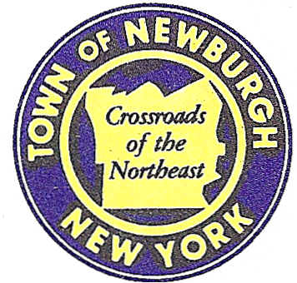

TOWN OF NEWBURGH
_______Crossroads of the Northeast __________________________
OLD TOWN HALL
308 GARDNERTOWN ROAD NEWBURGH, NEW YORK 12550

PLANNING BOARD
JOHN P. EWASUTYN, CHAIRMAN
TELEPHONE 845-564-7804
FAX 845-564-7802
E-MAIL: planningboard@townofnewburgh.org

PLANNING BOARD AGENDA

August 16th, 2018

*PLEASE NOTE: The Planning Board Meeting will start at 7:00 P.M. and all Applicants/Representatives
are to be present at that time. The Meeting will be held in the Meeting Room of Town Hall,
located at 1496 Route 300, Newburgh NY.*

- Dawes (18-08) LOT LINE REVISION
490 East Road
Section 6, Block 1, Lot 4
Zone: AR
Rep: Brooks & Brooks, Land Surveyors
11 Main St.
Highland, NY 12528

2. NPA Site Plan (17-03) SITE PLAN
NYS Route 747 Blvd.
Section 89, Block 1, Lot 80.2 & 80.1
Zone: IB
Rep: Zen Design Consultant, Inc.
6 Old North Plank Road
Newburgh, NY 12550

- Rockwood Drive Subdivision (11-19) PUBLIC HEARING
Rockwood Drive, North Plank Rd. & Chestnut Lane
Section 75, Block 1, Lot 36.2
Zone: R-3
Rep: Hudson Land Design, PC
13 Chambers St..
Newburgh, NY 12550

*WORK SESSION*
Project Readiness Discussion scheduled for 5:30 p.m. in the Meeting Room of
Town Hall on Thursday, August 16th, 2018.*

PLANNING BOARD BUSINESS
WORK SESSION

.

.

*WORK SESSION*
Project Readiness Discussion scheduled for 5:30 p.m. in the Meeting Room of
Town Hall on Thursday, August 16th, 2018.*

